# ABC Call Volume Trend Analysis

**Final project-4**

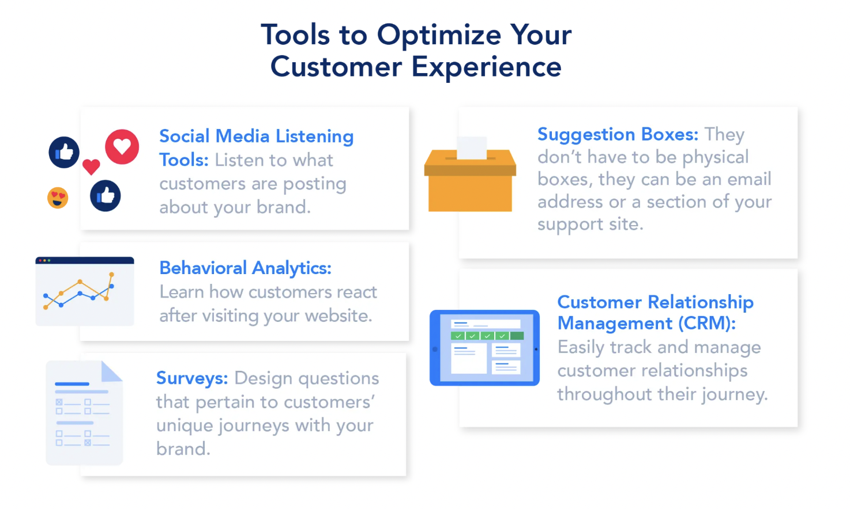

**By- ROHIT BAHUGUNA**

### About the project:

The attached dataset is of Inbound calls of an ABC company from the insurance category consists of a Customer Experience (CX) Inbound calling team for 23 days. Data includes Agent Name, Agent ID, Queue Time [duration for which customer have to wait before they get connected to an agent], Time [time at which call was made by customer in a day], Time Bucket [for easiness we have also provided you with the time bucket], Duration [duration for which a customer and executives are on call, Call Seconds [for simplicity we have also converted those time into seconds), call status (Abandon, answered, transferred).

A customer experience (CX) team consists of professionals who analyze customer feedback and data, and share insights with the rest of the organization. Typically, these teams fulfil various roles and responsibilities such as: Customer experience programs (CX programs), Digital customer experience, Design and processes, Internal communications, Voice of the customer (VOC), User experiences, Customer experience management, Journey mapping, Nurturing customer, interactions, Customer success, Customer support, Handling customer data, Learning about the customer journey.

Interactive Voice Response (IVR), Robotic Process Automation (RPA), Predictive Analytics, Intelligent Routing are some of the most impactful Al-empowered customer experience tools we can use in this project.

In a Customer Experience team there is a huge employment opportunity for Customer service representatives A.k.a. call Centre agents, customer service agents. Some of the roles for them include: Email support, Inbound support, Outbound support, social media support.

Inbound customer support is defined as the call Centre which is responsible for handling inbound calls of customers. Inbound calls are the incoming voice calls of the existing customers or prospective customers for our business which are attended by customer care representatives. Inbound customer service is the methodology of attracting, engaging, and delighting our customers to turn them into our business' loyal advocates. By solving our customers' problems and helping them achieve success using our product or service, we can delight our customers and turn them into a growth engine for our business.

### Approach:

In this analysis, the first step is to go through the data set, clearly understand the variables (i.e. column title and values) contained in the dataset. We will observe how given variable are related with case study and given task. We will analyze and make insights to answer the questions. The analysis can be done using statistical formulas and can also be done using Tech tools like MS-excel and MS-word.

### Tech-Stack Used:

* MS-Excel- it is used for data cleaning, visualization and analysis of the provided data.
* MS-Word- It helps in creating and editing document, and also helpful in making document interactive with tools.

### Analysis Outcome:

**Q1. Calculate the average call time duration for all incoming calls received by agents (in each Time Bucket).**

Solution:

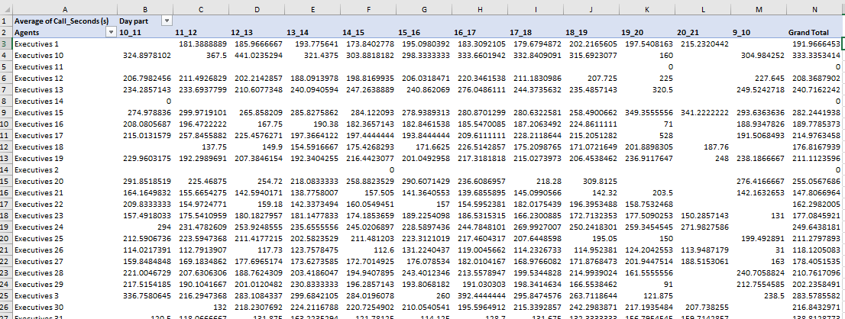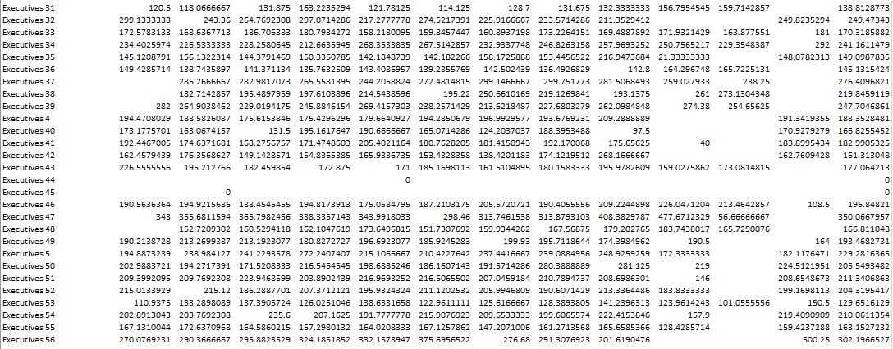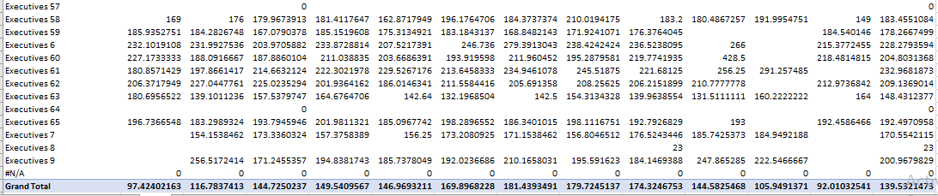

**Table: 1**

* Agents are measured in the Rows and average of Call Seconds is measured in the Values section for each day part time in columns. And call status in filter section.
* The total average of call time duration which are answered by the agents is 198.6 seconds and overall average call time duration is 139.53 seconds.
* The average call time duration for all incoming calls received by agents is the highest in between 10 am to 11 am and from 7 pm to 8 pm.
* The average call time duration for all incoming calls received by agents is the least in between 12 noon to 1 pm.
* Executive 47 has highest average call duration and Executive 8 has lowest average call duration.

**Q2. Show the total volume/ number of calls coming in via charts/ graphs [Number of calls v/s Time]. You can select time in a bucket form (i.e. 1-2, 2-3, ….).**

**Solution:**

**Figure-1**

* We plotted Time Bucket in the rows and took Count of phone number as their values.
* We measured Count of phone number as the Total call received in that duration.
* The customers call the most in between 11 am to 1 noon.
* The customers call the least in between 8 pm to 9 pm.

Assumption: An agent work for 6 days a week; On an average total unplanned leaves per agent is 4 days a month; An agent total working Hrs. is 9 Hrs. out of which 1.5 Hrs. goes into lunch and snacks in the office. On average an agent occupied for 60% of his total actual working Hrs. (i.e. 60% of 7.5 Hrs.) on call with customers/ users. Total days in a month is 30 days.

**Q3. As you can see current abandon rate is approximately 30%. Propose a manpower plan required during each time bucket [between 9am to 9pm] to reduce the abandon rate to 10%. (i.e. You have to calculate minimum number of agents required in each time bucket so that at least 90 calls should be answered out of 100).**

**Solution:** From the table-2 shown below, we know that 29% are Abandon call, 70% are answered and 1 % are transferred call. In order to reduce abandon rate to 10%, we have answer more number of all and for that we require more agents to attend more calls.

From this, we first have to find how many call received in each day and average number of call received having on the basis of call status.

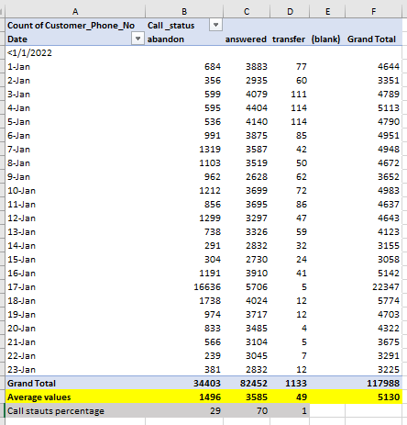

**Table-2**

From given assumption and above obtained table, we have calculated



**Table-3**

Time for 90% of call (in Hrs.) = (Average time to answer 70% call* total average call* 0.9)/3600

Agent required = [Time for 90% of call (in Hrs.)]/ working time for agent

Initially answering 70%, the agent required for that is: average call duration/ working time of agent

i.e. [(198.6* 5130*0.7)/3600]/4.5 = 44

for answer 90% of call: 198.6* 5130*0.9)/3600]/4.5 = 57

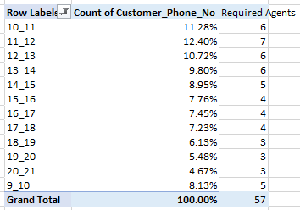

**Table- 4**

**So, the additional agents required are: 57-44 = 13.**

**Q4. Let’s say customers also call this ABC insurance company in night but didn’t get answer as there are no agents to answer, this creates a bad customer experience for this Insurance company. Suppose every 100 calls that customer made during 9 Am to 9 Pm, customer also made 30 calls in night between interval [9 Pm to 9 Am] and distribution of those 30 calls are as follows:**



**Now propose a manpower plan required during each time bucket in a day. Maximum Abandon rate assumption would be same 10%.**

**Solution:** The given data shows the call distribution in each hours between 9pm-9am.



**Table- 5**

From the previous data, we know the average time to answer calls in day time and from that we can calculate the time required for answering 90% calls, as there is 0.3 times calls in night so the time required to answer them should also be 0.3 times.

And to calculate agent required, we have to divide time required by work time of agents.

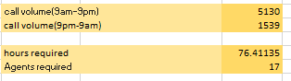

**Table-6**

So according to percent of call received in particular hour we calculated the agent required in each hour between 9pm to 9am.

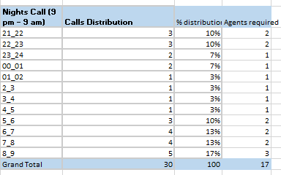

**Table-7**

**The total number of agents required between 9pm to 9am is 17.**

### Insights:

* The company can reduce the number of agents at evening time because of least calling at that duration.
* The company must divide working time of agents in 3 part, for efficient use of manpower.
* The employees who are working 9 am to 9 pm. The manager can change some of the workers shift from 5 am to 2 pm and some workers from 2 pm to 11 pm to get the most calls answered.
* The company can shift some of the day workers for the night shift.

### Results:

* I learned about the behavioral analytics.
* I have also learned to use pivot table and pivot charts more effectively.
* I got to know about the IVR Duration, which is an Al tool, who answer the calls to get to know the customer exact question and then transfer it to the right agent to get the customer's queries get answered.
* This project was easy to get the answers as the data provided by the team have already calculated the time bucket and converted the calls duration into seconds, so we do not have to spend time on it to calculate.
* I have learned how to analyze the call Centre data and report to the management.

### Drive link: <https://drive.google.com/drive/folders/1Qxd9DrKMDOPSmxqB8dVwMp_yB00T0XfI?usp=share_link>